
WDT Project

Breadth First Search (BFS) Algorithm Analysis

For Egy Metro Guide Project

Member name | ID
Abd Alrahman Saed Alsayed | 202302377
Mahmoud Mohamed Hegazy | 202302612
Mahmoud Fawzy Mahmoud | 202302484
Ali Yasser Mohamed | 202305666
Abdullah Ibrahiem Gaballah | 202302701

Supervised by: Dr Hossam Eladly

Breadth First Search (BFS) Algorithm Analysis

1. Definition
Breadth First Search (BFS) is an algorithm used for traversing or searching elements in a Graph or Tree data structure.

The main idea of BFS is visiting nodes level by level starting from a source node. Instead of going deep into one path, BFS explores all neighboring nodes first, then moves to the next level.

2. Purpose of BFS
BFS is commonly used for:
- Finding the shortest path in an unweighted graph
- Network routing
- Social network analysis
- Navigation systems
- Artificial Intelligence search problems
- Game development

In metro routing systems, BFS can be used to determine the minimum number of stations between two stations.

3. How BFS Works
BFS uses a Queue data structure and follows the FIFO (First In First Out) principle.

Algorithm Steps:
1. Start from the source node.
2. Add it to a queue.
3. Mark it as visited.
4. Remove the first node from the queue.
5. Visit all its neighbors.
6. If a neighbor has not been visited, add it to the queue.
7. Repeat the process until the queue becomes empty.

4. Example
Example Graph:
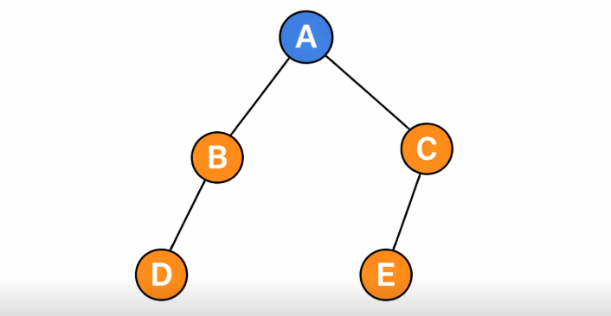

BFS Traversal Order:
A → B → C → D → E

This means the algorithm visits the first node, then all its neighbors, then moves to the next level.

5. Time Complexity
The time complexity of BFS is:

O(V + E)

Where:
V = number of vertices (nodes)
E = number of edges (connections)

This means BFS processes each node once and each edge once.

6. Space Complexity
The space complexity of BFS is:

O(V)

Because the algorithm stores visited nodes and the queue during traversal.

7. Graph Representation
BFS usually works with an Adjacency List representation.

Example:

A → B , C
B → D
C → E

This representation is efficient for memory usage and traversal speed.

8. BFS in Metro Systems
In a metro routing system:

Nodes represent stations.
Edges represent connections between stations.

Example:
Helwan → Ain Helwan → Helwan University

BFS can determine the minimum number of stations between two locations.

Breadth First Search (BFS) can be used to find the minimum number of stations between two locations. The algorithm starts from the source station and explores all neighboring stations first, then continues level by level until the destination station is reached

9. BFS Implementation in C#
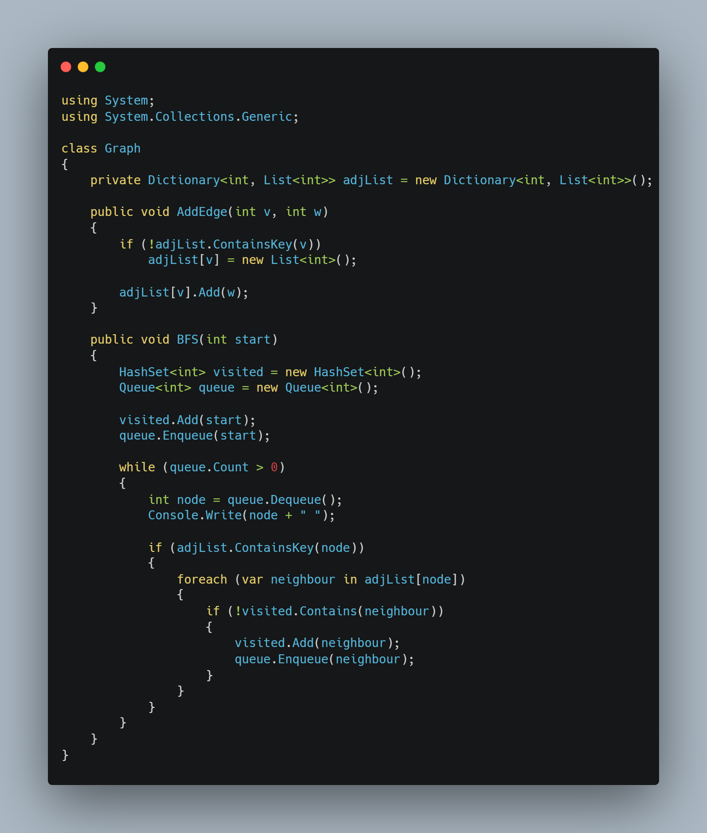

Example Output
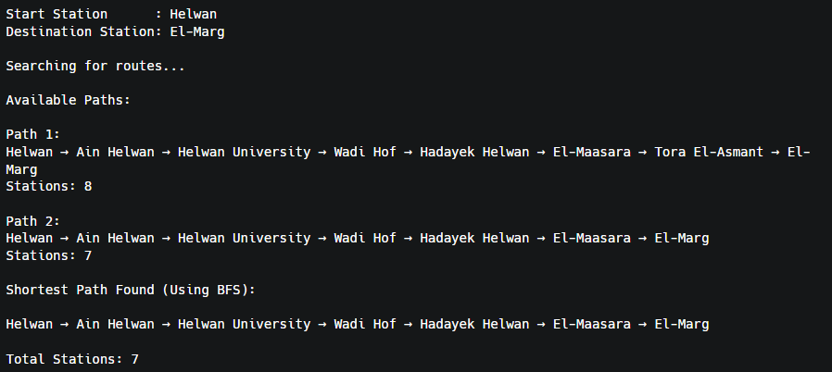

10. C# Libraries Used
Common libraries used in BFS implementation:

System.Collections.Generic

Important data structures:
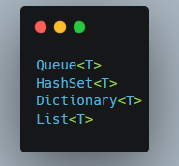
External graph libraries that may also be used:
QuickGraph
QuikGraph

12. Advantages
1. Simple and easy to implement.
2. Guarantees the shortest path in unweighted graphs.
3. Efficient for small and medium graphs.
4. Useful in network traversal.

13. Disadvantages
1. Not suitable for weighted graphs.
2. High memory usage with very large graphs.
3. Does not consider travel time or distance.

14. Difference Between BFS and Dijkstra
Feature BFS Dijkstra
Graph Type Unweighted Weighted
Shortest Path Yes Yes
Data Structure Queue Priority Queue
Time Complexity O(V + E) O(E log V)

